**Phase 4: Process Automation (Admin)**

Validation rules: It is checking if the end time <= start time it will show error

End_Time__c <= Start_Time__c

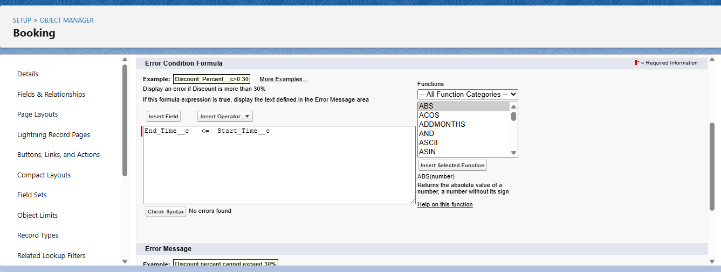

This will show the error message “End Date must be after Start Date.”

Flow builder : Record-Triggered Flow

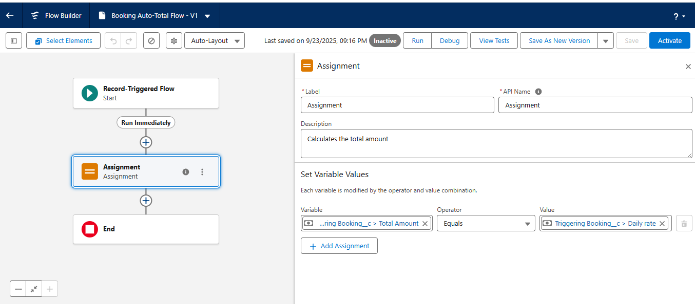

Setting variable values as “Total_Amount__c = (End_Date__c - Start_Date__c) * Daily_Rate__c”

Creating Approval process for Booking:

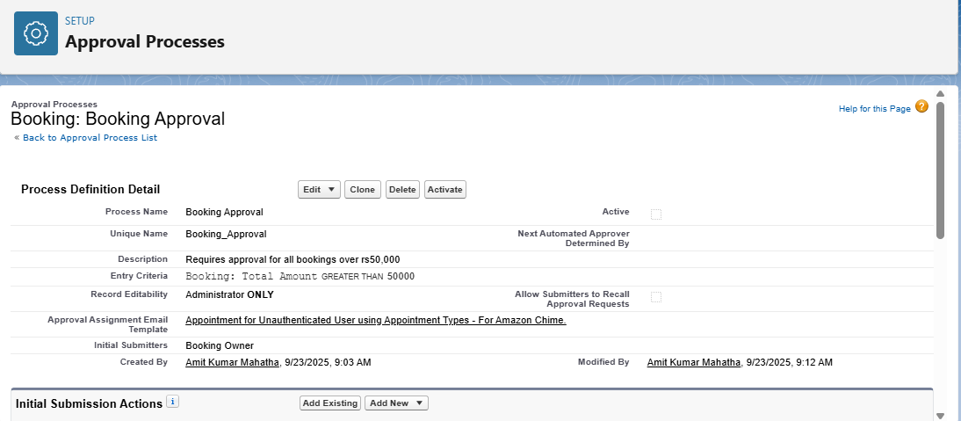

Booking approval is sent if the total amount is greater than rs50000

Email Templates:

Selecting classic email templates and creating new templates

